**Credit cards**

Credit cards are a significant component of the U.S. banking sector, providing consumers with a convenient method of payment and financial flexibility. They are widely used for everyday purchases, emergencies, and financing large expenses.

1. **Definition**:
   * Credit cards are payment cards issued by financial institutions that allow cardholders to borrow funds to pay for goods and services. The borrowed amount must be repaid with interest unless a grace period applies.
2. **Types of Credit Cards**:
   * **Standard Credit Cards**: Basic cards with no rewards or special features.
   * **Rewards Credit Cards**: Offer points, miles, or cashback on purchases.
   * **Secured Credit Cards**: Require a security deposit and are designed for individuals with poor or no credit history.
   * **Business Credit Cards**: Tailored for business expenses and often come with additional benefits for business owners.
   * **Student Credit Cards**: Designed for college students, usually with lower credit limits and introductory benefits.

**Key Players**

1. **Issuing Banks**:
   * **JPMorgan Chase**: Offers a variety of credit cards, including the popular Chase Sapphire and Freedom series.
   * **Bank of America**: Provides a range of cards, including cash rewards and travel cards.
   * **Citibank**: Known for its Citi Double Cash and Citi Premier cards.
   * **Wells Fargo**: Offers a mix of rewards and cashback cards.
2. **Credit Card Networks**:
   * **Visa**: One of the largest payment networks, widely accepted globally.
   * **Mastercard**: Another major payment network with extensive global acceptance.
   * **American Express (AmEx)**: Known for premium cards with high rewards and benefits.
   * **Discover**: Offers cards with no annual fees and cashback rewards.

**Market Trends**

1. **Interest Rates**:
   * Credit card interest rates are generally high compared to other types of loans, often ranging from 15% to 25% APR, depending on the cardholder's creditworthiness.
2. **Rewards and Benefits**:
   * Increasing competition among issuers has led to enhanced rewards programs, including higher cashback percentages, travel perks, and exclusive access to events.
   * Issuers also offer sign-up bonuses, 0% introductory APR periods, and no foreign transaction fees to attract customers.
3. **Technology Integration**:
   * Contactless payments and mobile wallets (e.g., Apple Pay, Google Wallet) are becoming more popular.
   * Enhanced security features, such as EMV chips and tokenization, are widely implemented to protect against fraud.
4. **Credit Card Debt**:
   * The total revolving credit card debt in the U.S. has been increasing, reflecting consumer spending habits and economic conditions. It reached over $1 trillion in recent years.
5. **Regulatory Environment**:
   * The Credit Card Accountability Responsibility and Disclosure (CARD) Act of 2009 introduced various consumer protections, including clearer disclosure of terms and restrictions on certain fees and interest rate increases.

**Management Strategies**

**Lenders' Strategies:**

1. **Risk Management**:
   * Issuers use credit scoring models to assess the creditworthiness of applicants.
   * Implement credit limits and interest rates based on risk profiles.
2. **Customer Acquisition and Retention**:
   * Offer attractive sign-up bonuses, rewards programs, and introductory APR periods.
   * Provide excellent customer service and dispute resolution processes to retain customers.
3. **Technology and Innovation**:
   * Invest in mobile and online platforms for easy account management.
   * Use advanced fraud detection and prevention technologies.
4. **Credit Monitoring and Education**:
   * Offer free credit scores and credit monitoring services.
   * Provide financial education resources to help customers manage their credit responsibly.

**Borrowers' Strategies:**

1. **Responsible Usage**:
   * Pay off balances in full each month to avoid interest charges.
   * Use rewards strategically to maximize benefits without overspending.
2. **Credit Management**:
   * Monitor credit reports regularly to ensure accuracy and detect fraud.
   * Maintain a good credit score by making timely payments and keeping credit utilization low.
3. **Shopping for the Best Card**:
   * Compare interest rates, fees, rewards, and benefits across different cards.
   * Choose cards that align with spending habits and financial goals.

**Key Statistics**

1. **Interest Rates**:
   * Average credit card interest rates range from 15% to 25%, depending on the card type and the borrower’s credit score.
2. **Market Size**:
   * There are over 500 million credit card accounts in the U.S., with the total revolving credit card debt exceeding $1 trillion.
3. **Delinquency Rates**:
   * Credit card delinquency rates have varied, generally remaining below 3% in recent years, though they can increase during economic downturns.

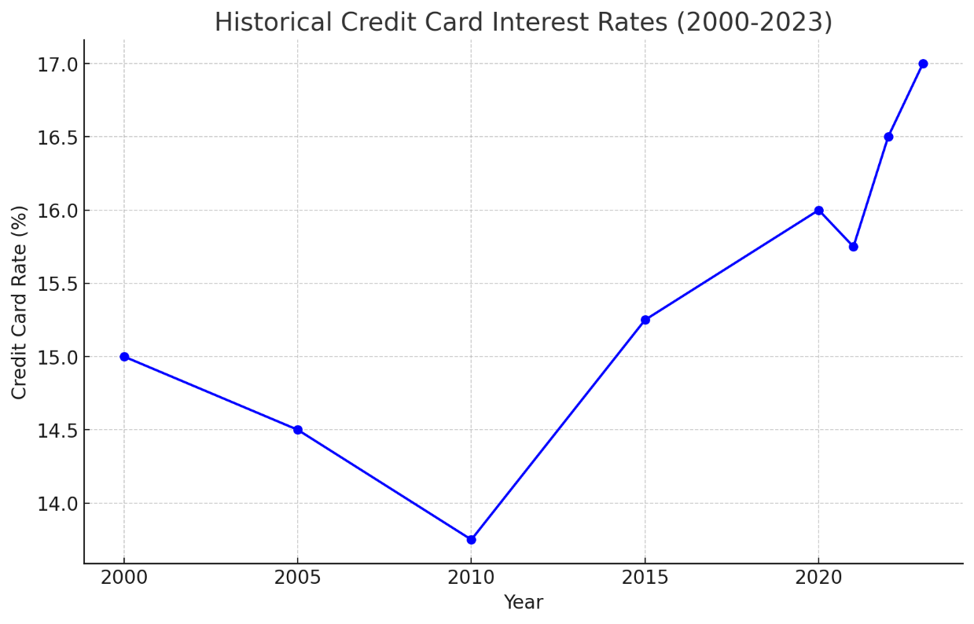

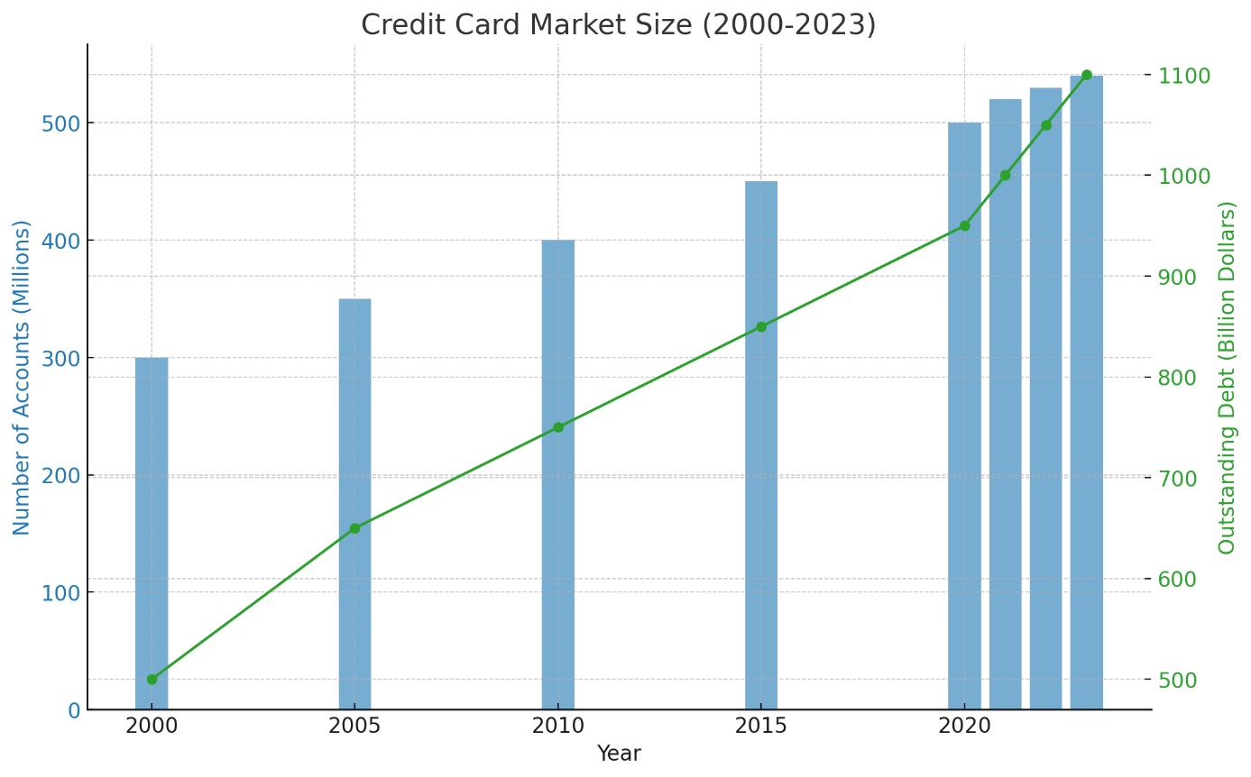

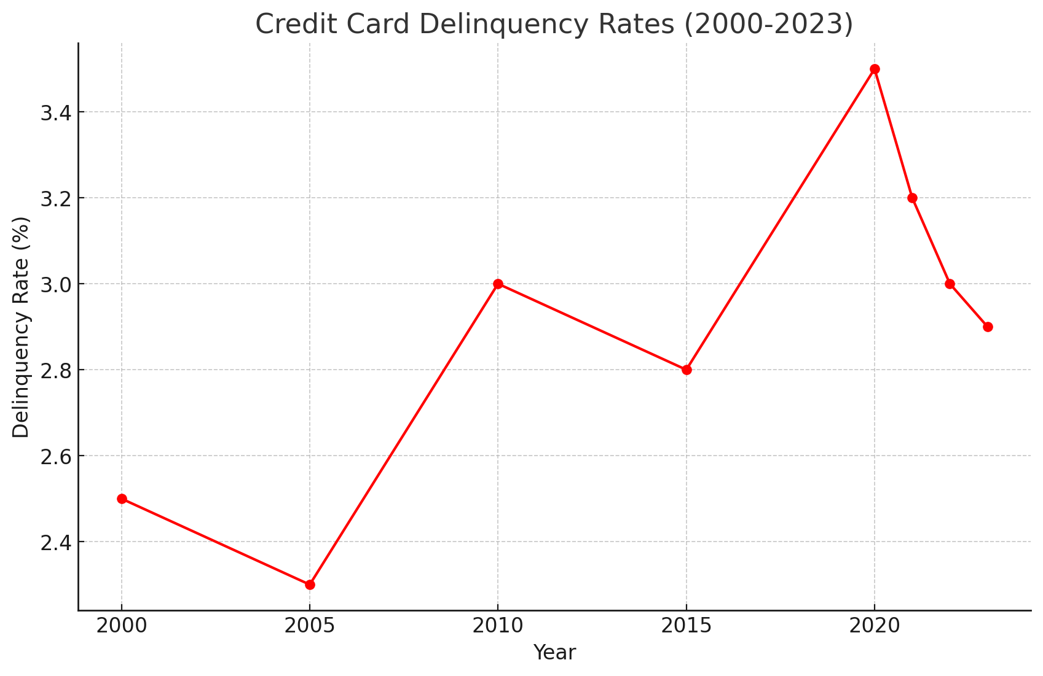

• **Historical Credit Card Interest Rates (2000-2023)**:

* Credit card interest rates have varied over the past two decades, generally ranging from 13.75% to 17.00%.

• **Credit Card Market Size (2000-2023)**:

* The number of credit card accounts has grown from 300 million in 2000 to 540 million in 2023.
* Outstanding credit card debt has increased from $500 billion in 2000 to $1.1 trillion in 2023.

• **Credit Card Delinquency Rates (2000-2023)**:

* Delinquency rates have fluctuated, peaking at 3.5% in 2020 and decreasing to 2.9% in 2023.

**Key Statistics**

1. **Interest Rates**:
   * Average credit card interest rates range from 13.75% to 17.00% over the past two decades.
2. **Market Size**:
   * There are 540 million credit card accounts in the U.S. as of 2023.
   * Outstanding credit card debt has reached $1.1 trillion in 2023.
3. **Delinquency Rates**:
   * Credit card delinquency rates peaked at 3.5% in 2020 and have since declined to 2.9% in 2023.

**Examples of Credit Card Issuers**

1. **JPMorgan Chase**:
   * **Chase Sapphire Preferred**: Popular for travel rewards and benefits.
   * **Chase Freedom Unlimited**: Offers cashback on every purchase.
2. **Bank of America**:
   * **Bank of America Cash Rewards**: Provides cashback on groceries, gas, and online shopping.
   * **Bank of America Travel Rewards**: Offers points for travel-related expenses.
3. **Citibank**:
   * **Citi Double Cash**: Rewards customers with cashback on all purchases.
   * **Citi Premier Card**: Provides points on travel and dining expenses.
4. **American Express**:
   * **The Platinum Card**: Known for premium travel benefits and rewards.
   * **Blue Cash Preferred Card**: Offers high cashback on groceries and streaming services.
5. **Capital One**:
   * **Capital One Venture Rewards**: Known for travel rewards and flexibility.
   * **Capital One Quicksilver**: Offers unlimited cashback on all purchases.